**UI Design:**

**Calendar View - Monthly appointment calendar**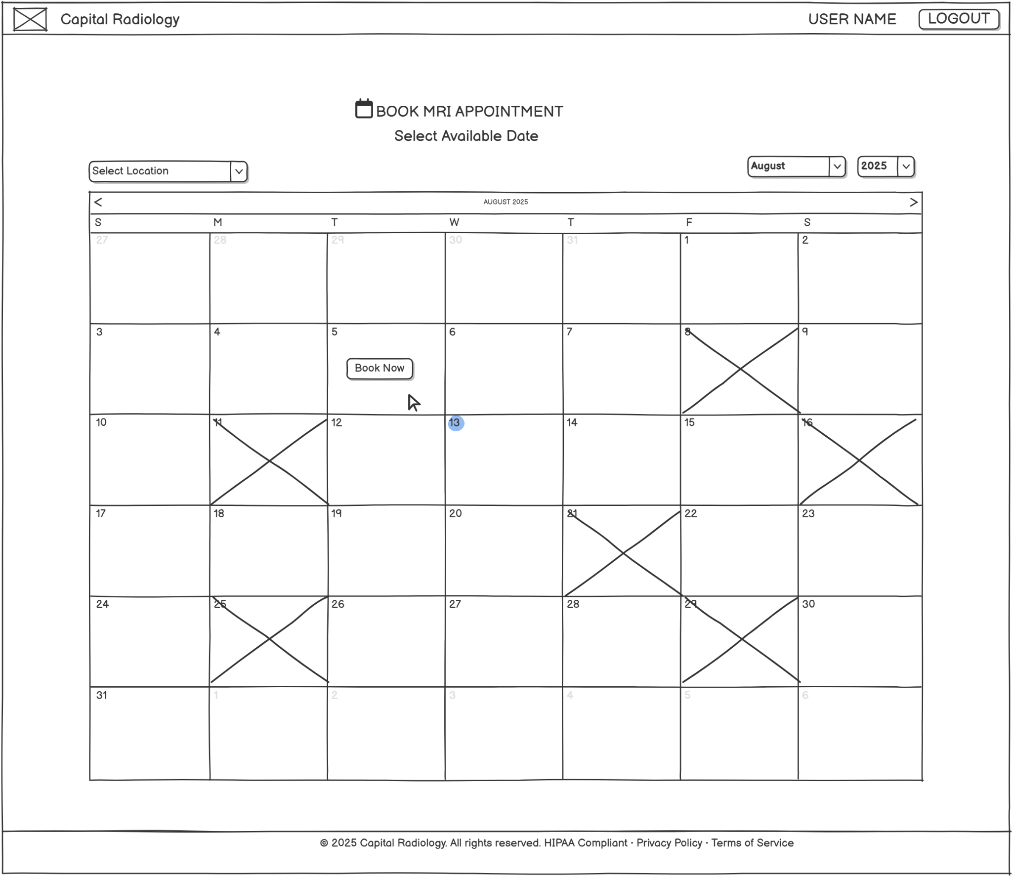

**Booking Form - Appointment details and preferences**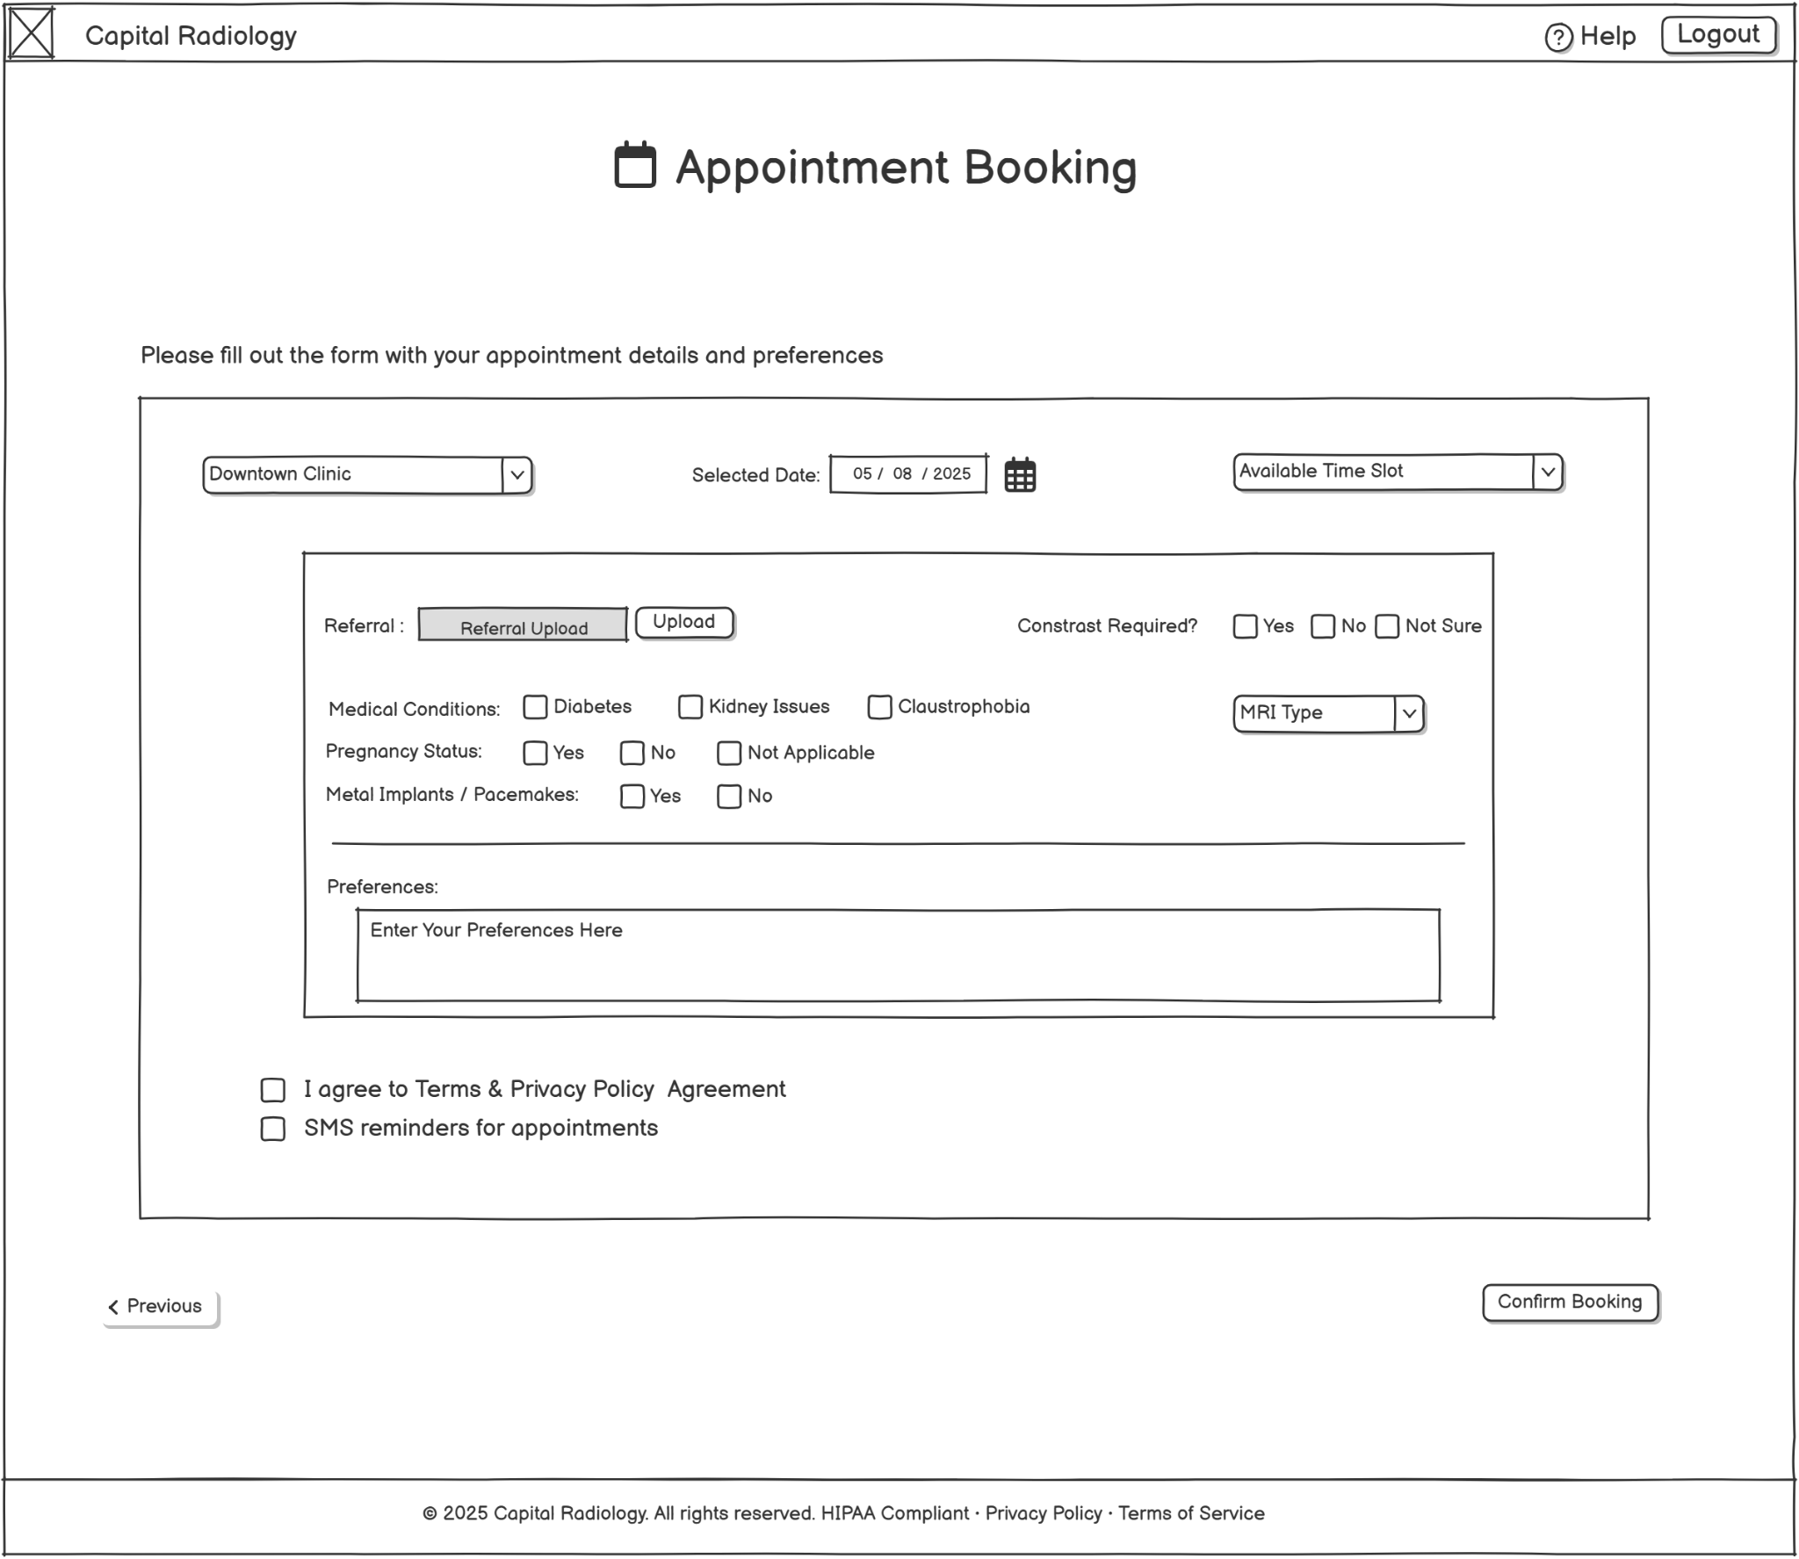

**Schedule Management - Staff appointment overview**

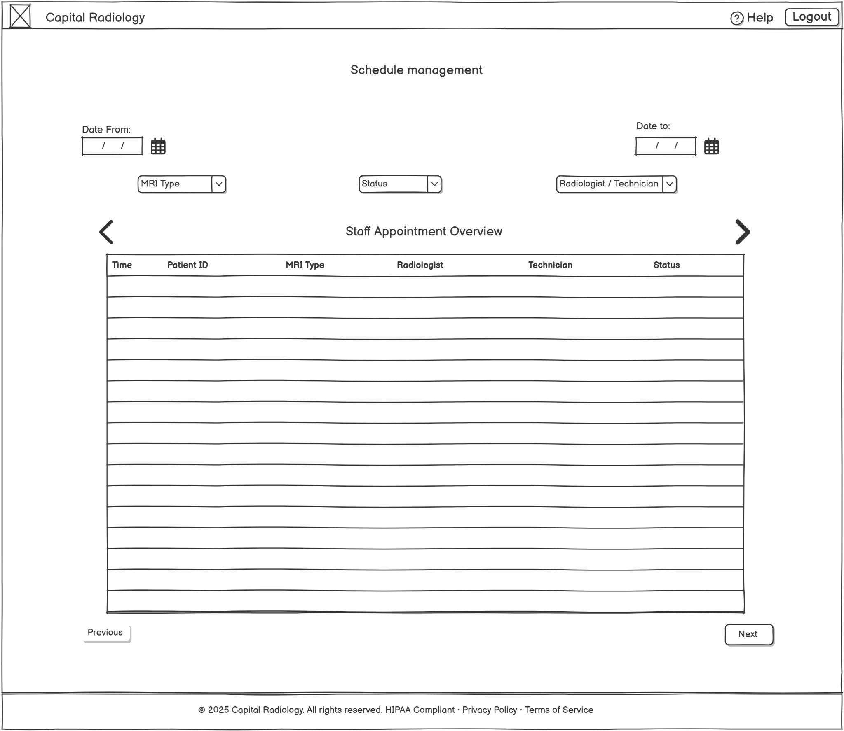

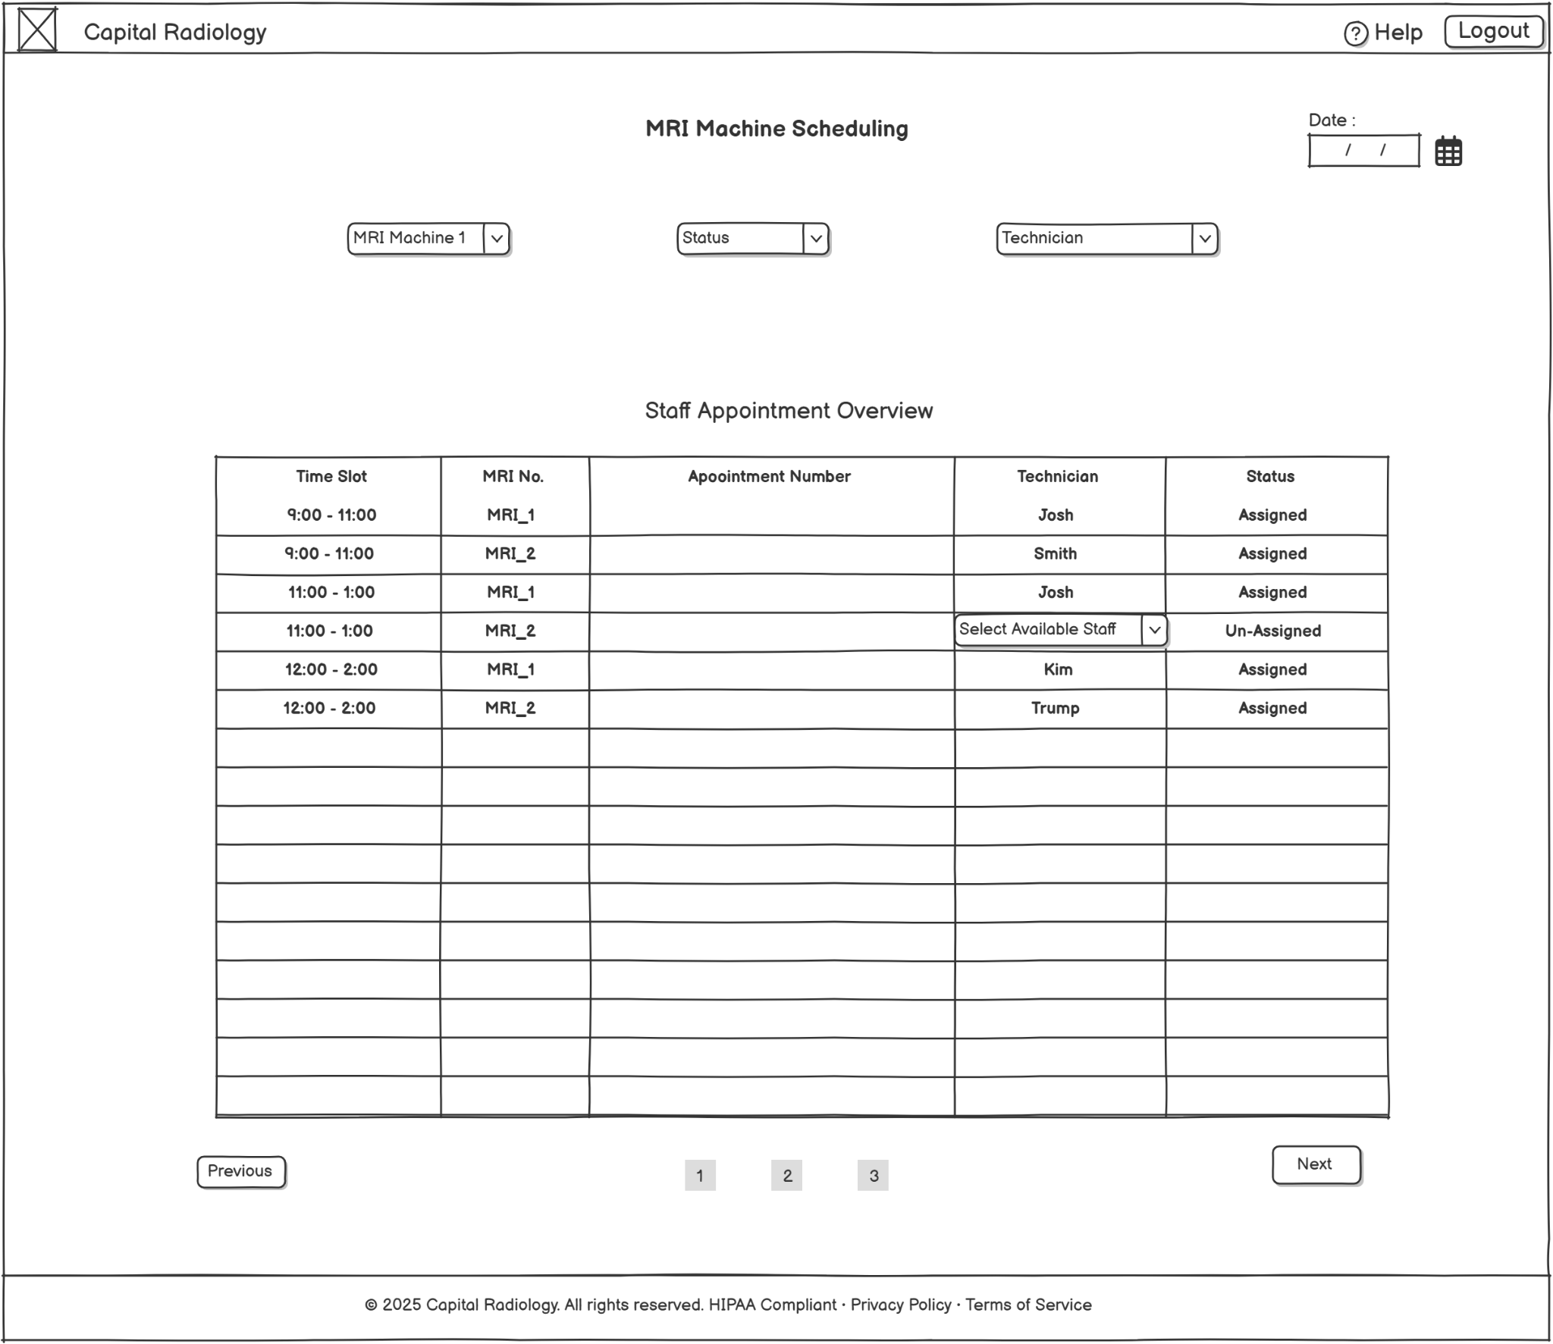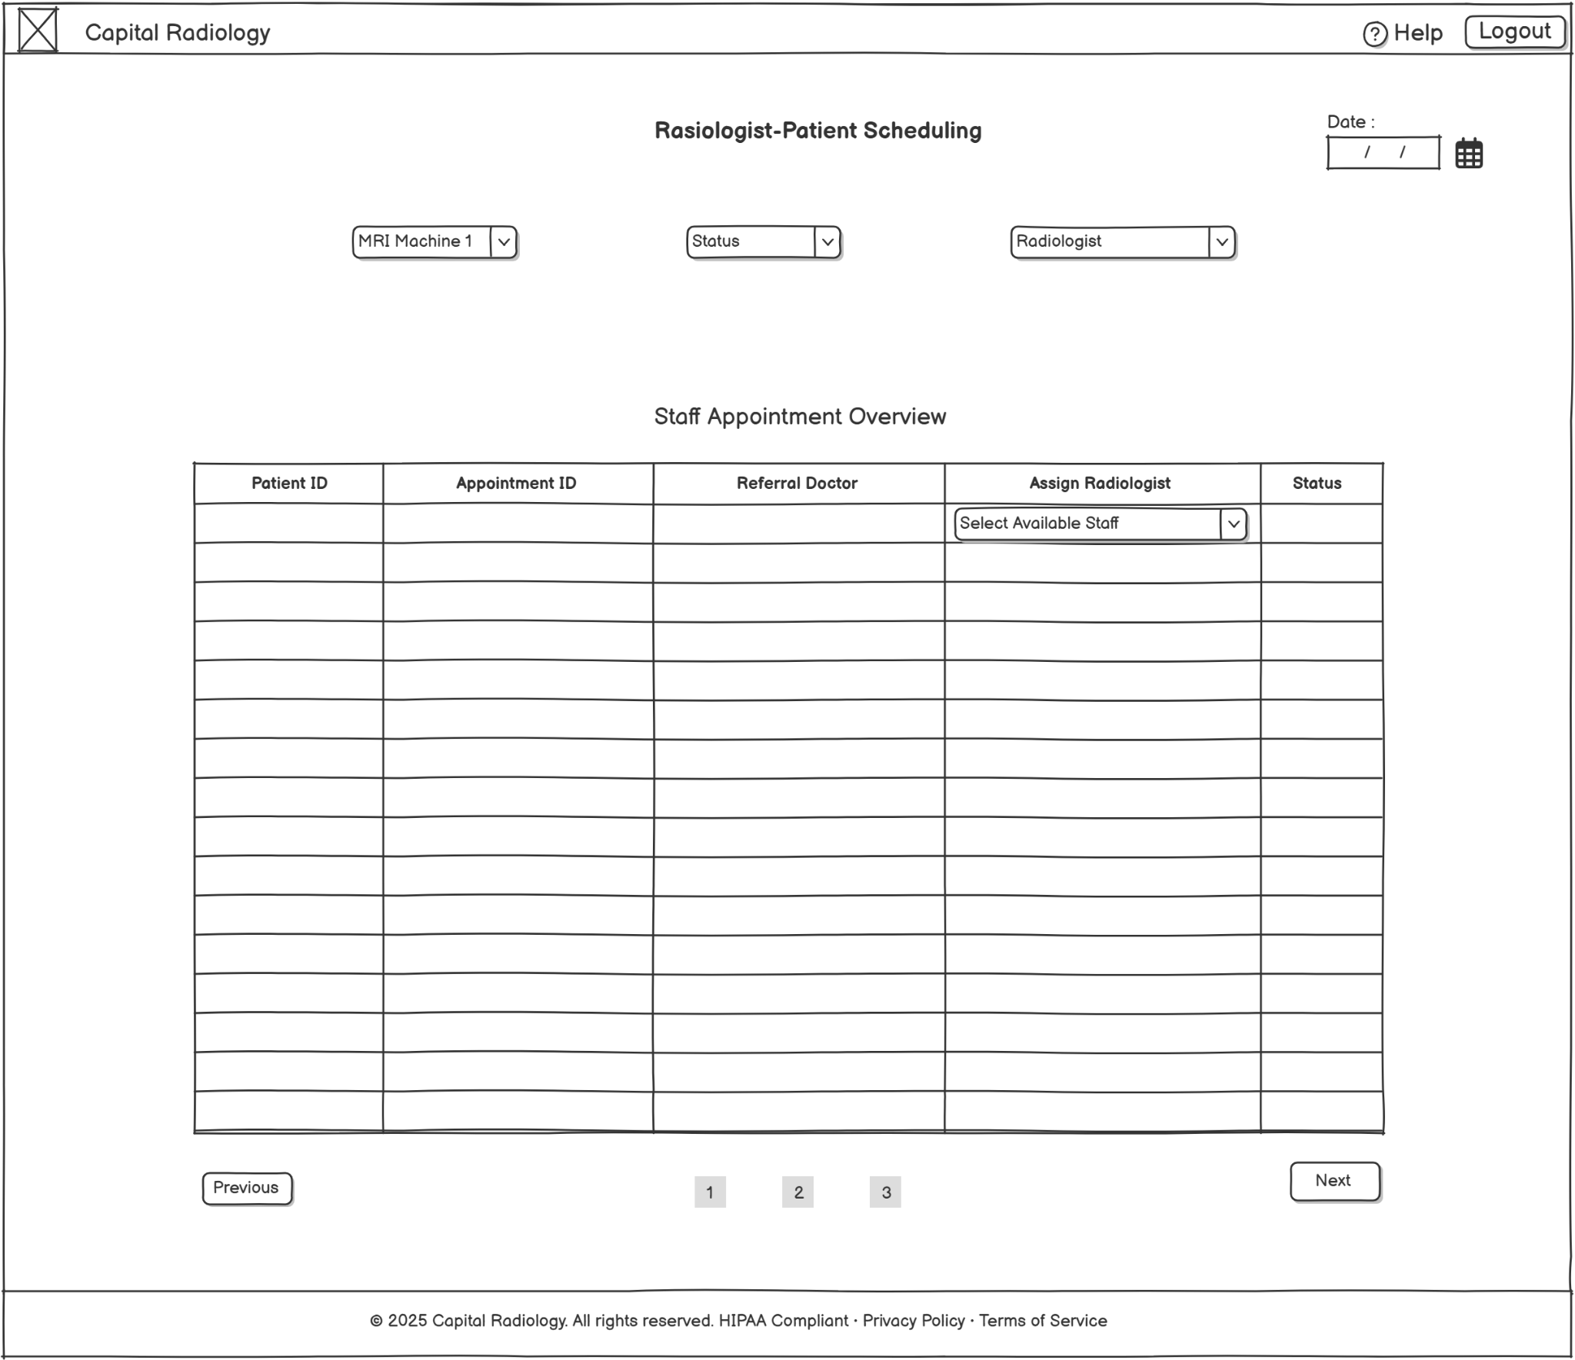

**Notification Settings - Reminder configuration panel**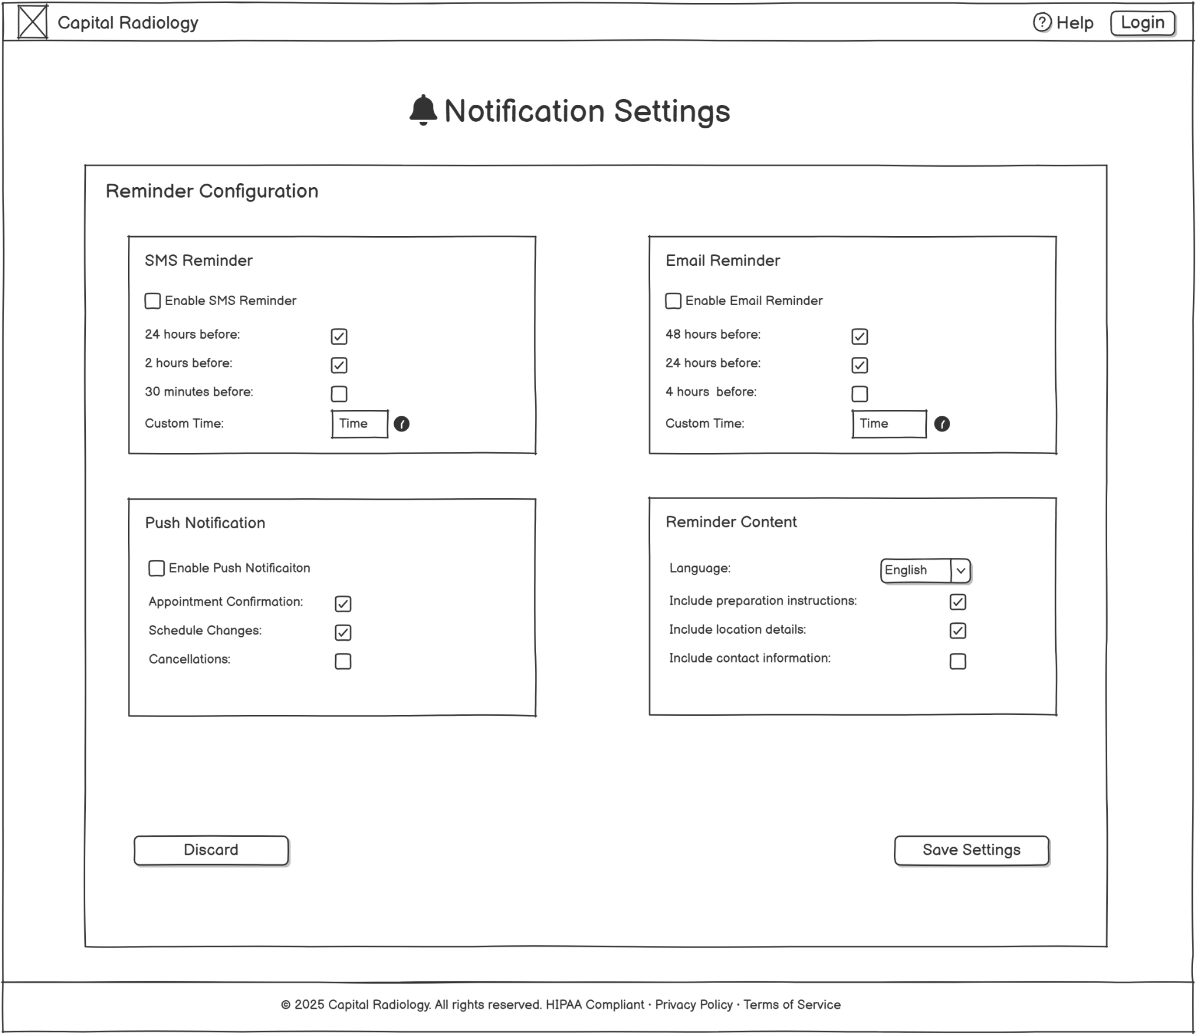

**Forms Design :**

**Input Form: Schedule modification form**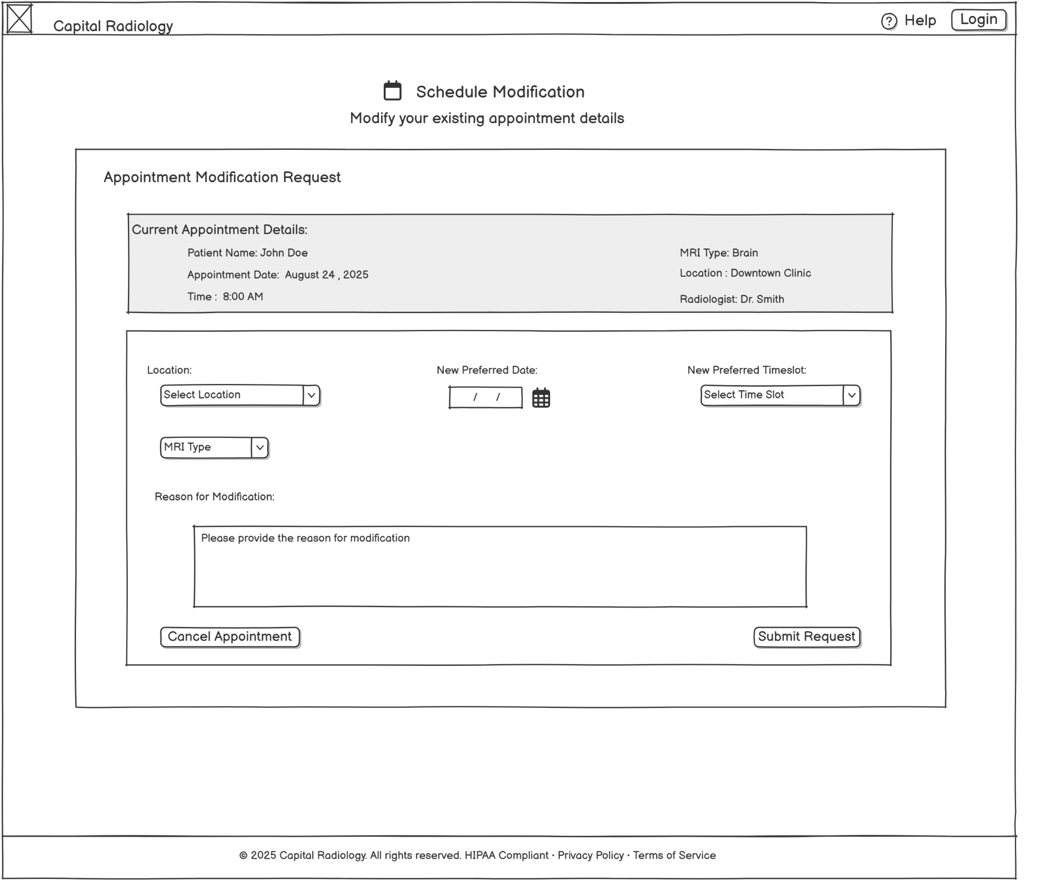

**Output Form: Booking confirmation template**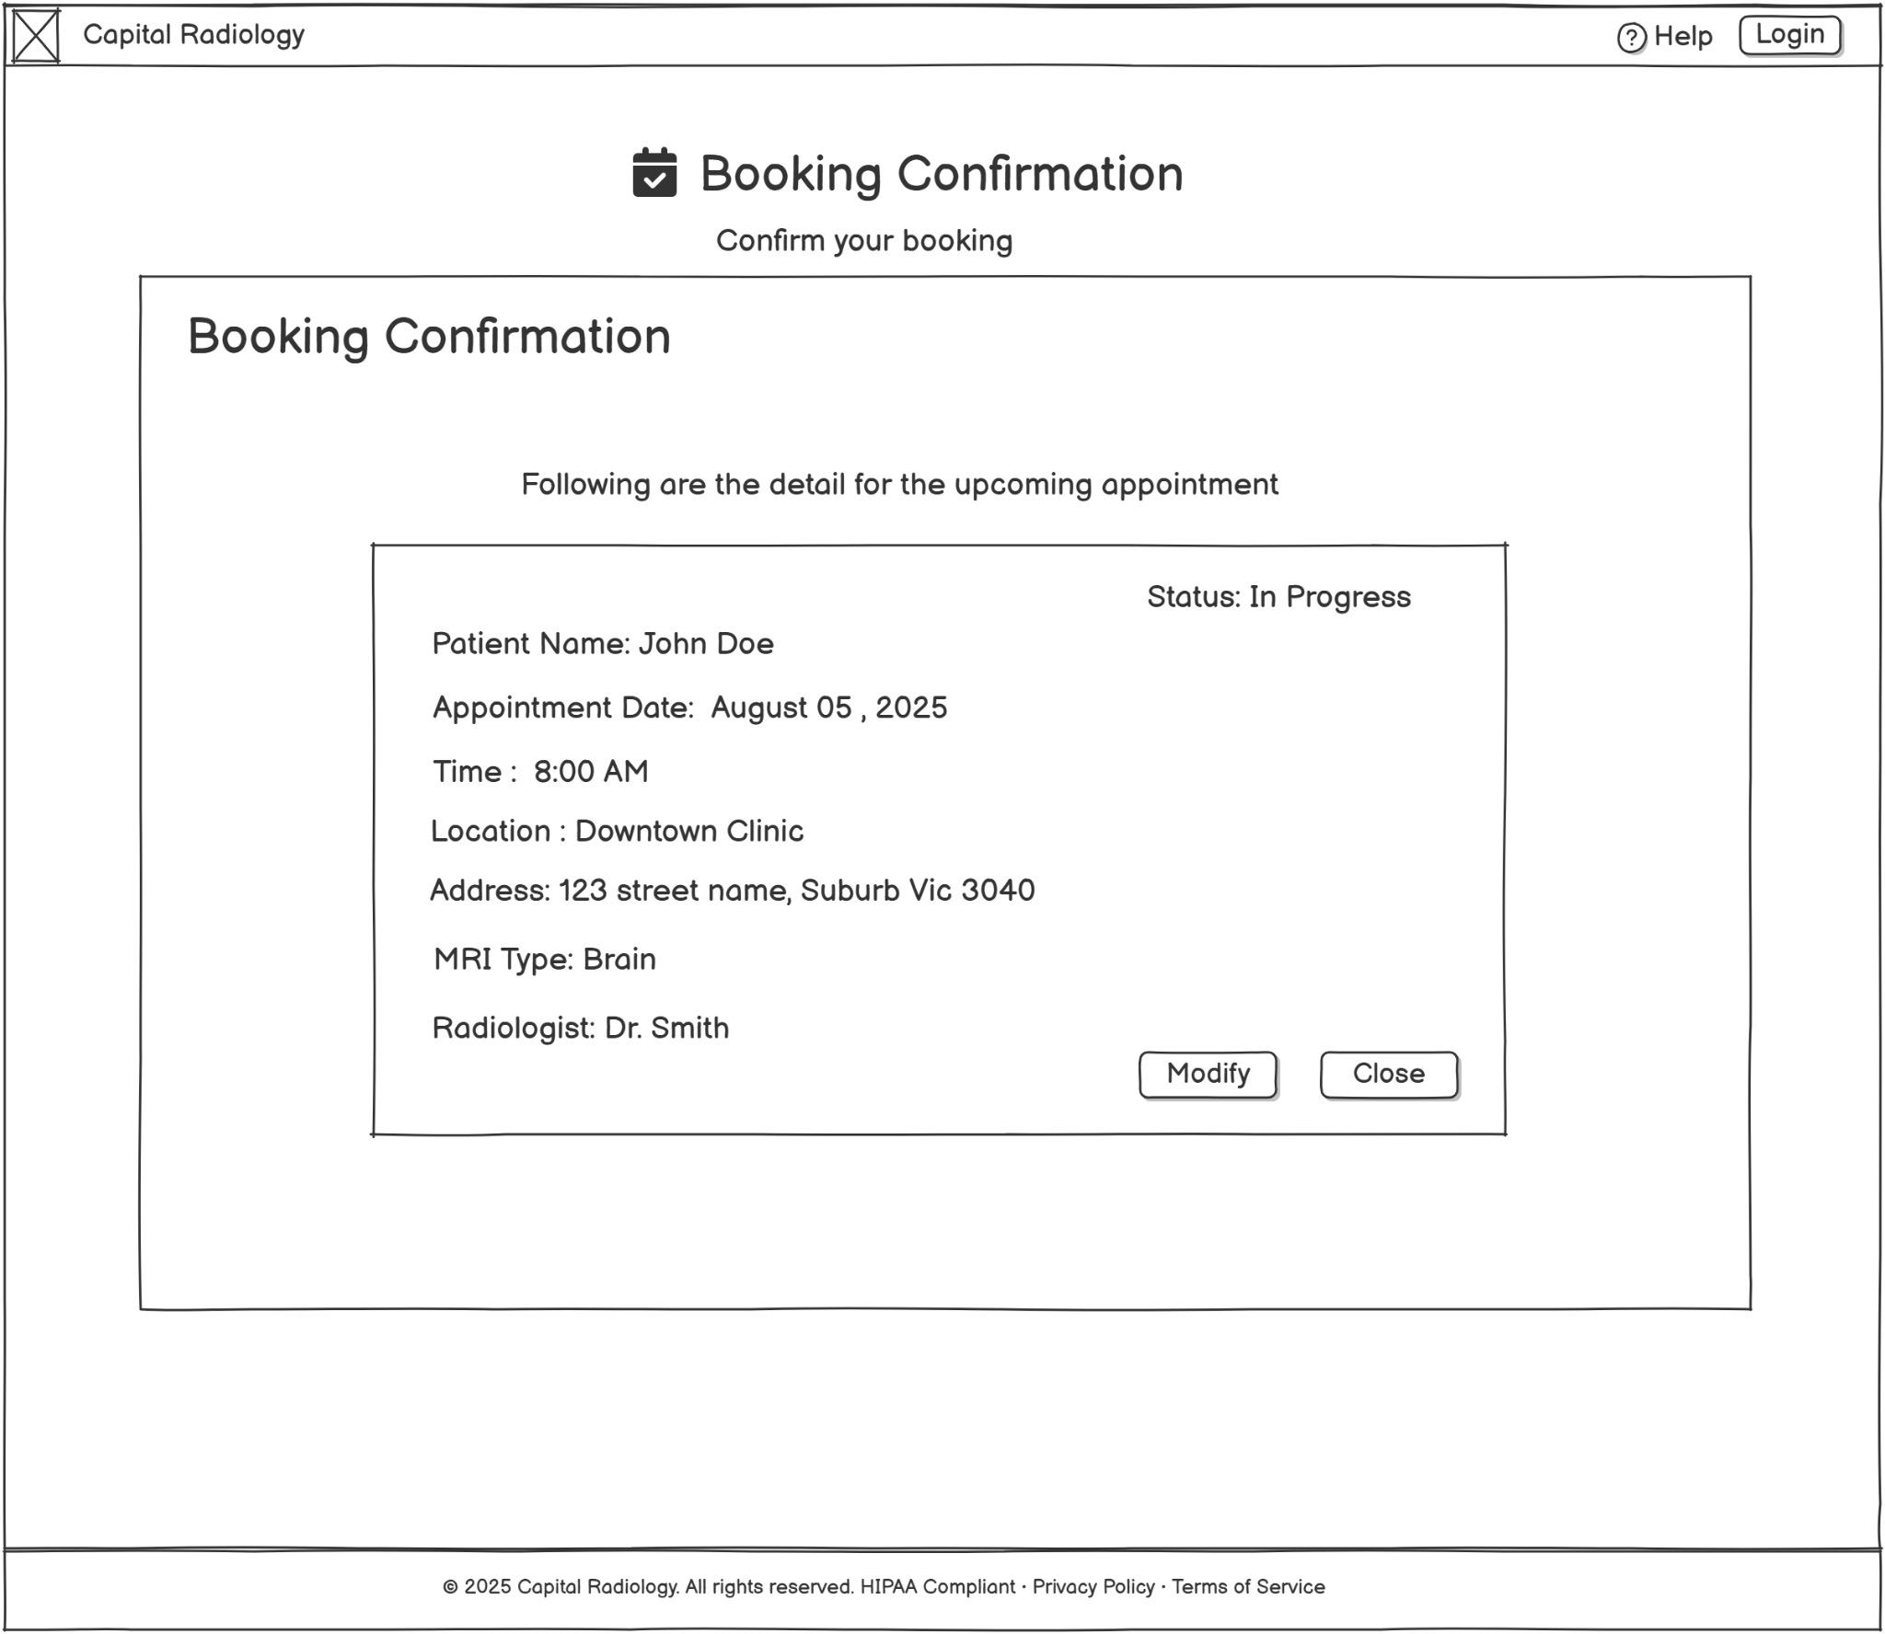

**Output Form: Schedule reports**

**StoryBoarding:**